EXPERIMENT – 3
ONLINE BUS TICKET BOOKING SYSTEM

AIM
To design and implement a simple Online Bus Ticket Booking System using HTML, CSS, and JavaScript that allows users to search for buses, enter passenger details, book seats, view booking history, and cancel the latest booking.

PROCEDURE
- Create a project folder named OnlineBusBooking.
- Open Notepad or a code editor and create a file named index.html.
- Write the HTML code to create the bus search form, passenger details form, seat selection, and booking history.
- Use CSS to style the page, forms, buttons, and booking result messages.
- Use JavaScript to validate the search details and display sample bus information.
- Implement ticket booking by checking whether the passenger name is entered and whether the selected seat is available.
- Display a booking confirmation with passenger name, seat number, and booking ID.
- Display booking history and implement cancellation of the latest booking.
- Save the file and open index.html in a web browser.
- Test bus search, successful booking, duplicate-seat prevention, booking history, and cancellation.

CODE
Save the following complete code as index.html.
<!DOCTYPE html>
<html lang="en">
<head>
<meta charset="UTF-8">
<meta name="viewport" content="width=device-width, initial-scale=1.0">
<title>Online Bus Ticket Booking System</title>
<style>
body {
font-family: Arial, sans-serif;
background: #f2f4f8;
margin: 0;
}
header {
background: #123c69;
color: white;
text-align: center;
padding: 20px;
}
.container {
max-width: 650px;
margin: 30px auto;
background: white;
padding: 25px;
border-radius: 10px;
box-shadow: 0 3px 10px #cccccc;
}
h2 { color: #123c69; }
label {
display: block;
margin-top: 15px;
font-weight: bold;
}
input, select {
width: 100%;
padding: 10px;
margin-top: 5px;
box-sizing: border-box;
}
button {
background: #123c69;
color: white;
padding: 12px;
border: none;
border-radius: 5px;
margin-top: 15px;
cursor: pointer;
}
.cancel { background: #c62828; }
.result {
background: #e8f5e9;
padding: 15px;
margin-top: 15px;
border-radius: 5px;
}
footer {
text-align: center;
padding: 15px;
color: #555;
}
</style>
</head>
<body>
<header>
<h1>Online Bus Ticket Booking System</h1>
<p>Search, Book and Manage Your Bus Tickets</p>
</header>

<div class="container">
<h2>1. Search for Buses</h2>
<label>From</label>
<input type="text" id="from" placeholder="Enter source city">

<label>To</label>
<input type="text" id="to" placeholder="Enter destination city">

<label>Travel Date</label>
<input type="date" id="date">

<button onclick="searchBus()">Search Bus</button>
<div id="busResult"></div>

<hr>

<h2>2. Book Your Ticket</h2>
<label>Passenger Name</label>
<input type="text" id="passenger" placeholder="Enter passenger name">

<label>Select Seat</label>
<select id="seat">
<option value="1">Seat 1</option>
<option value="2">Seat 2</option>
<option value="3">Seat 3</option>
<option value="4">Seat 4</option>
<option value="5">Seat 5</option>
</select>

<button onclick="bookTicket()">Book Ticket</button>
<button class="cancel" onclick="cancelTicket()">Cancel Last Booking</button>
<div id="message"></div>

<hr>
<h2>3. Booking History</h2>
<ul id="history"><li>No bookings yet.</li></ul>
</div>

<footer>
<p>Online Bus Ticket Booking System | Lab Experiment</p>
</footer>

<script>
const bookedSeats = new Set();
const bookings = [];

function searchBus() {
const from = document.getElementById("from").value.trim();
const to = document.getElementById("to").value.trim();
const date = document.getElementById("date").value;

if (!from || !to || !date) {
alert("Please enter source, destination and travel date.");
return;
}
if (from.toLowerCase() === to.toLowerCase()) {
alert("Source and destination must be different.");
return;
}

document.getElementById("busResult").innerHTML = `
<div class="result">
<h3>Bus Available!</h3>
<p><b>Bus Name:</b> Express Travels</p>
<p><b>From:</b> ${from}</p>
<p><b>To:</b> ${to}</p>
<p><b>Travel Date:</b> ${date}</p>
<p><b>Departure:</b> 10:00 PM</p>
<p><b>Ticket Price:</b> ₹750</p>
<p><b>Total Seats:</b> 5 (Demo)</p>
</div>`;
}

function bookTicket() {
const name = document.getElementById("passenger").value.trim();
const seat = document.getElementById("seat").value;
const message = document.getElementById("message");

if (!name) {
alert("Please enter passenger name.");
return;
}
if (bookedSeats.has(seat)) {
alert("This seat is already booked. Please select another seat.");
return;
}

const booking = { name: name, seat: seat, id: Date.now() };
bookings.push(booking);
bookedSeats.add(seat);

message.innerHTML = `
<div class="result">
<h3>Booking Successful!</h3>
<p>Passenger: ${name}</p>
<p>Seat Number: ${seat}</p>
<p>Booking ID: ${booking.id}</p>
</div>`;
updateHistory();
}

function cancelTicket() {
const message = document.getElementById("message");

if (bookings.length === 0) {
alert("No bookings available to cancel.");
return;
}

const booking = bookings.pop();
bookedSeats.delete(booking.seat);

message.innerHTML = `
<div class="result">
<h3>Booking Cancelled</h3>
<p>Passenger: ${booking.name}</p>
<p>Seat Number: ${booking.seat}</p>
</div>`;
updateHistory();
}

function updateHistory() {
const history = document.getElementById("history");
history.innerHTML = "";

if (bookings.length === 0) {
history.innerHTML = "<li>No bookings yet.</li>";
return;
}

bookings.forEach(function(booking) {
const item = document.createElement("li");
item.textContent = booking.name + " - Seat " + booking.seat +
" - Booking ID: " + booking.id;
history.appendChild(item);
});
}
</script>
</body>
</html>

IMPEMENTATION
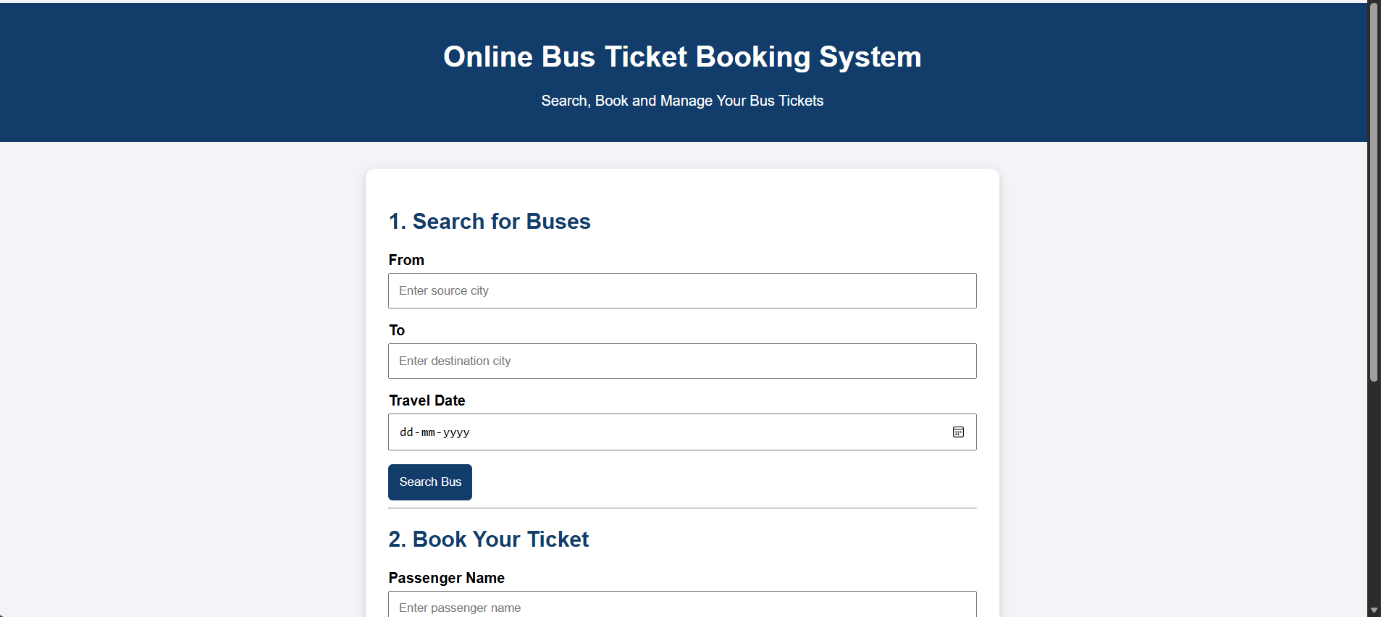
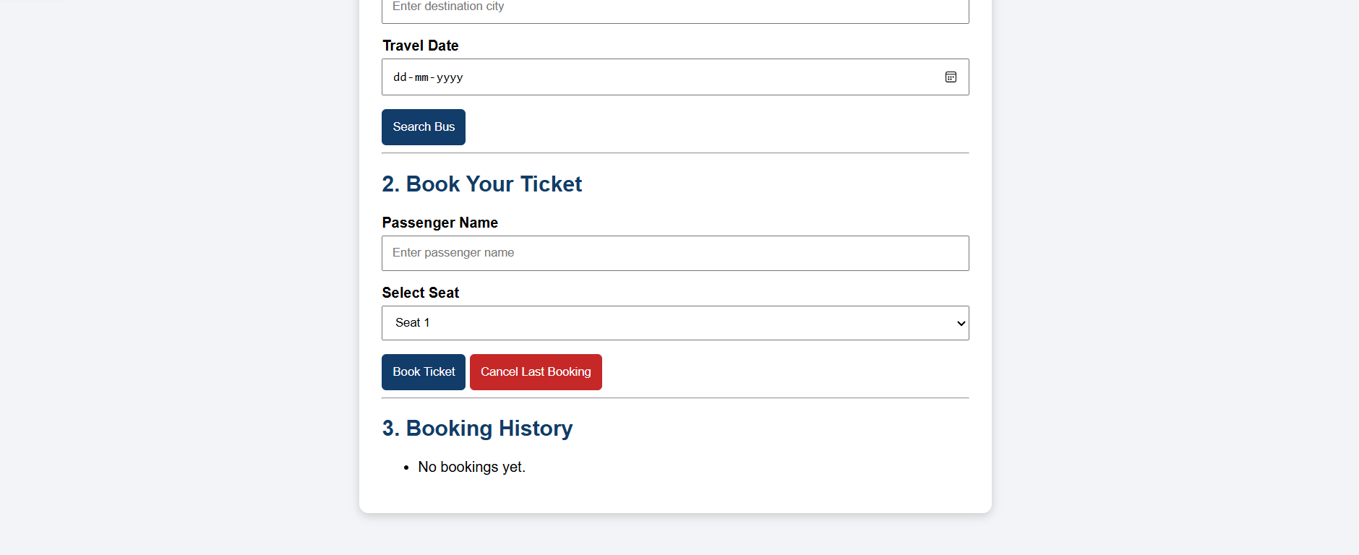

RESULT
The Online Bus Ticket Booking System prototype was implemented successfully using HTML, CSS, and JavaScript. The program demonstrates bus searching, seat selection, ticket booking, booking history, duplicate-seat checking, and ticket cancellation.

